1. Memorize all the escape sequences by putting them on flash cards.

| **Escape** | **What it does.** |
| --- | --- |
| \\ | Backslash () |
| \' | Single-quote (') |
| \" | Double-quote (") |
| \a | ASCII bell (BEL) |
| \b | ASCII backspace (BS) |
| \f | ASCII form feed (FF) |
| \n | ASCII linefeed (LF) |
| \r | ASCII Carriage Return (CR) |
| \t | ASCII Horizontal Tab (TAB) |
| \uxxxx | Character with 16-bit hex value xxxx (Unicode only) |
| \v | ASCII vertical tab (VT) |
| \ooo | Character with octal value ooo |
| \xhh | Character with hex value hh |

2.Use ''' (triple-single-quote) instead. Can you see why you might use that instead of """?

It might be readable and make the code readable.

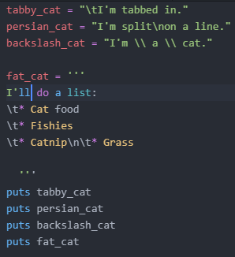

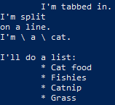

3.Combine escape sequences and format strings to create a more complex format

